**Prerequisites**

* VS Code
* node JS
* git bash
* angular cli

**Task 1**

* Create a basic Angular application using Angular CLI
* Install and configure bootstrap in the Angular app created
* Clear App component (use container style from bootstrap to wrap content inside app component)
* Create a new component manually (use bootstrap jumbotron style)
* Create a new component with cli (use bootstrap card style)
* Use the two components in App component
* Use (or explore) bootstrap styles (button etc.)

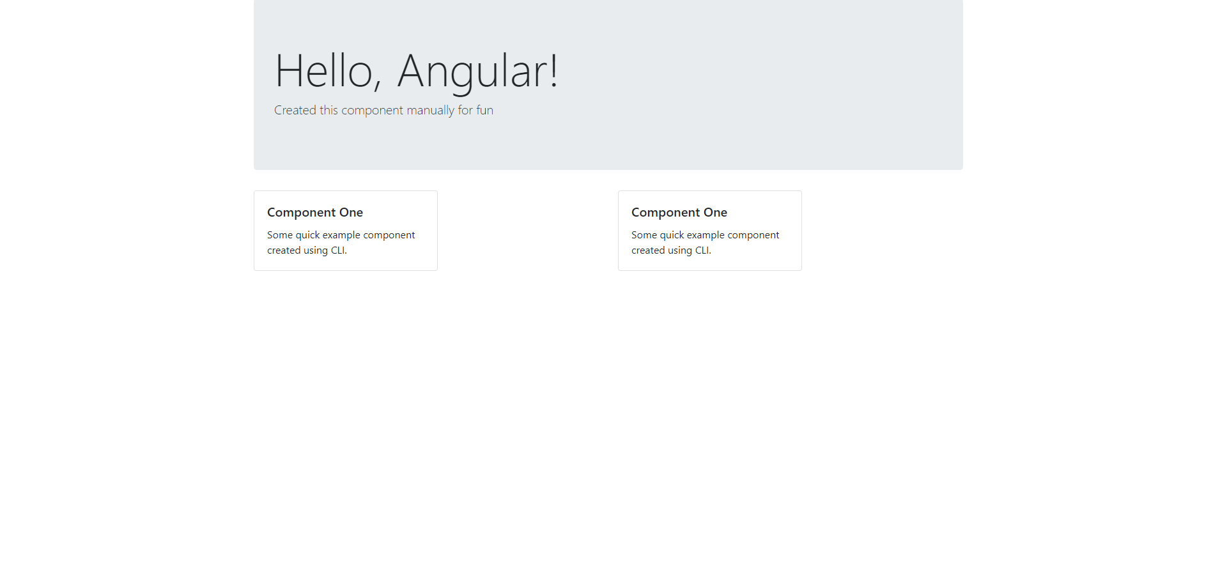

**Evaluation Criteria**

**2**: Angular default application is up and working

**3**: Bootstrap is installed and configured to be used with some demonstration

**4**: Created two components one manually and another using CLI

**5**: Application looks exactly like in the mockup which is build using recommended bootstrap styles